Chapter
Managing Inventory

Discussion Questions
1. The four types of inventory are:
- Raw material—items that are to be converted into product
- Work-in-process (WIP)—items that are in the process of being converted
- Finished goods—completed items for which title has not been transferred
- MRO—(maintenance, repair, and operating supplies)—items that are necessary to keep the transformation process going
2. The advent of low-cost computing should not be seen as
obviating the need for the ABC inventory classification scheme. Although the cost of computing has decreased considerably, the cost of data acquisition has not decreased in a similar fashion. Business organizations still have many items for which the cost of data acquisition for a “perpetual” inventory system is still considerably higher than the cost of the item.
3. The purpose of the ABC system is to identify those items that require more attention due to cost or volume.
4. Types of costs—holding cost: cost of capital invested and space required; shortage cost: the cost of lost sales or customers who never return; the cost of lost good will; ordering cost: the costs associated with ordering, transporting, and receiving the items; unit cost: the actual cost of the item.
5. Assumptions of EOQ model: demand is known and constant over time; lead time is known and constant; receipt of inventory is instantaneous; quantity discounts are not possible; the only variable costs are the costs of placing an order or setting up production and the cost of holding or storing inventory over time and if orders are placed at the right time, stockouts or shortages can be completely avoided.
6. The EOQ increases as demand increases or as the setup cost increases; it decreases as the holding cost increases. The changes in the EOQ are proportional to the square root of the changes in the parameters.
7. Price times quantity is not variable in the EOQ model, but is in the discount model. When quality discounts are available, the unit purchase price of the item depends on the order quantity.
8. Advantages of cycle counting:
1. Eliminating the shutdown and interruption of production necessary for annual physical inventories
2. Eliminating annual inventory adjustments
3. Providing trained personnel to audit the accuracy of
inventory
4. Allowing the cause of errors to be identified and remedial action to be taken
5. Maintaining accurate inventory records
9. A decrease in setup time decreases the cost per order, encourages more and smaller orders, and thus decreases the EOQ.
10. Discount points below the EOQ have higher inventory costs, and the prices are no lower than at the EOQ. Points above the EOQ have higher inventory costs than the corresponding price break point or EOQ at prices that are no lower than either of the price breaks or the EOQ. (It depends on whether there exists a discount point above the EOQ.)
11. Service level refers to the percent of customers to whom the product or service is delivered when and as promised.
12. If the same costs hold, more will be ordered using an economic production quantity, because the average inventory is less than the corresponding EOQ system.
13. In a fixed-quantity inventory system, when the quantity on hand reaches the reorder point, an order is placed for the specified quantity. In a fixed-period inventory system, an order is placed at the end of the period. The quantity ordered is that needed to bring on-hand inventory up to a specified level.
14. The EOQ model gives quite good results under inexact inputs; a 10% error in actual demand alters the EOQ by less than 5%.
15. Safety stock is inventory beyond average demand during lead time, held to control the level of shortages when demand and/or lead time are not constant; inventory carried to assure that the desired service level is reached.
16. The reorder point is a function of: demand per unit of time, lead time, customer service level, and standard deviation of demand.
17. Most retail stores have a computerized cash register (point-of-sale) system. At the time of purchase, the computer system simultaneously rings up the bill and reduces the inventory level in its records for the products sold.
18. Advantage of a fixed period system: There is no physical count of inventory when items are withdrawn. Disadvantage: There is a possibility of stockout during the time between orders.
Ethical Dilemma
Setting service levels to meet inventory demand is a manager’s job. Setting an 85% service level for whole blood is an important
judgment call on the part of the hospital administrator. Another major disaster means a certain shortage, yet any higher level may be hard to cost justify. Many hospitals do develop joint or regional groups to share supplies. The basic issue is how to put a price tag on lifesaving medicines. This is not an easy question to answer, but it makes for good discussion.
Active Model Exercises
ACTIVE MODEL 12.1: Economic Order Quantity (EOQ) Model
1. What is the EOQ and what is the lowest total cost?
EOQ = 200 units with a cost of $100
2. What is the annual cost of carrying inventory at the EOQ and the annual cost of ordering inventory at the EOQ of 200 units?
$50 for carrying and also $50 for ordering
3. From the graph, what can you conclude about the relationship between the lowest total cost and the costs of ordering and carrying inventory?
The lowest total cost occurs where the ordering and
inventory costs are the same.
4. How much does the total cost increase if the store manager orders 50 more hypodermics than the EOQ? 50 fewer hypodermics?
Ordering more increases costs by $2.50 or 2.5%. Ordering fewer increases costs by $4.17 or 4.17%
5. What happens to the EOQ and total cost when demand is doubled? When carrying cost is doubled?
The EOQ rises by 82 units (41%) and the total cost rises by $41 (41%) in either case.
6. Scroll through lower setup cost values and describe the changes to the graph. What happens to the EOQ?
The curves seem to drop and move to the left. The EOQ decreases.
7. Comment on the sensitivity of the EOQ model to errors in demand or cost estimates.
The total cost is not very sensitive to mistakes in forecasting demand or placing orders.
ACTIVE MODEL 12.2: Production Order Quantity Model
1. What is the optimal production run size for hubcaps?
283
2. How does this compare to the corresponding EOQ model?
The run size is larger than the corresponding EOQ.
3. What is the minimal cost?
$70.71
4. How does this compare to the corresponding EOQ model?
The total cost is less than the cost for the equivalent EOQ model.
End-of-Chapter Problems
12.1 An ABC system generally classifies the top 70% of dollar volume items as A, the next 20% as B, and the remaining 10% as C items. Similarly, A items generally constitute 20% of total number of items, B items are 30%; and C items are 50%.
Item Code Number |  | Average Dollar | Volume | Percent of Total $ Volume
1289 | → | 400 × 3.75 = | 1,500.00 | 44.0%
2347 | → | 300 × 4.00 = | 1,200.00 | 36.0%
2349 | → | 120 × 2.50 = | 300.00 | 9.0%
2363 | → | 75 × 1.50 = | 112.50 | 3.3%
2394 | → | 60 × 1.75 = | 105.00 | 3.1%
2395 | → | 30 × 2.00 = | 60.00 | 1.8%
6782 | → | 20 × 1.15 = | 23.00 | 0.7%
7844 | → | 12 × 2.05 = | 24.60 | 0.7%
8210 | → | 8 × 1.80 = | 14.40 | 0.4%
8310 | → | 7 × 2.00 = | 14.00 | 0.4%
9111 | → | 6 × 3.00 = | 18.00 | 0.5%
 |  |  | $3,371.50 | 100%  (rounded)
The company can make the following classifications:
A: 1289, 2347 (18% of items; 80% of dollar-volume).
B: 2349, 2363, 2394, 2395 (36% of items; 17.2% of dollar-volume).
C: 6782, 7844, 8210, 8310, 9111 (45% of items; 2.7% of dollar-volume).
12.2 (a) You decide that the top 20% of the 10 items, based on a criterion of demand times cost per unit, should be A items. (In this example, the top 20% constitutes only 58% of the total inventory value, but in larger samples the value would probably approach 70% to 80%.) You therefore rate items F3 and G2 as A items. The next 30% of the items are A2, C7, and D1; they represent 23% of the value and are categorized as B items. The remaining 50% of the items (items B8, E9, H2, I5, and J8) represent 19% of the value and become C items.
 | Annual
Item | Demand | Cost ($) | Demand × Cost | Classification
A2 | 3,000 | 50 | 150,000 | B
B8 | 4,000 | 12 | 48,000 | C
C7 | 1,500 | 45 | 67,500 | B
D1 | 6,000 | 10 | 60,000 | B
E9 | 1,000 | 20 | 20,000 | C
F3 | 500 | 500 | 250,000 | A
G2 | 300 | 1,500 | 450,000 | A
H2 | 600 | 20 | 12,000 | C
I5 | 1,750 | 10 | 17,500 | C
J8 | 2,500 | 5 | 12,500 | C

(b) Borecki can use this information to manage his A and B items more closely and to save ordering costs on his less
important C items by ordering only when A or B items are being ordered from the same supplier.
(c) A2 could easily move to the A category based on annual dollar volume. In a small sample, 30% of the items can be placed in the A category if deemed appropriate.
12.3

Inventory  Item | $Value per Case | #Ordered  per  Week | Total $  Value/Week | (52 Weeks)  Total = ($*52) | Rank | Percent of  Inventory | Cumulative  Percent of  Inventory
Fish filets | 143 | 10 | $1,430 | $74,360 | 1 | 17.54% | 17.54%
French fries | 43 | 32 | $1,376 | $71,552 | 2 | 16.88% | 34.43%
Chickens | 75 | 14 | $1,050 | $54,600 | 3 | 12.88% | 47.31%
Prime rib | 166 | 6 | $996 | $51,792 | 4 | 12.22% | 59.53%
Lettuce (case) | 35 | 24 | $840 | $43,680 | 5 | 10.31% | 69.83%
Lobster tail | 245 | 3 | $735 | $38,220 | 6 | 9.02% | 78.85%
Rib eye steak | 135 | 3 | $405 | $21,060 | 7 | 4.97% | 83.82%
Bacon | 56 | 5 | $280 | $14,560 | 8 | 3.44% | 87.25%
Pasta | 23 | 12 | $276 | $14,352 | 9 | 3.39% | 90.64%
Tomato sauce | 23 | 11 | $253 | $13,156 | 10 | 3.10% | 93.74%
Tablecloths | 32 | 5 | $160 | $8,320 | 11 | 1.96% | 95.71%
Eggs (case) | 22 | 7 | $154 | $8,008 | 12 | 1.89% | 97.60%
Oil | 28 | 2 | $56 | $2,912 | 13 | 0.69% | 98.28%
Trashcan liners | 12 | 3 | $36 | $1,872 | 14 | 0.44% | 98.72%
Garlic powder | 11 | 3 | $33 | $1,716 | 15 | 0.40% | 99.13%
Napkins | 12 | 2 | $24 | $1,248 | 16 | 0.29% | 99.42%
Order pads | 12 | 2 | $24 | $1,248 | 17 | 0.29% | 99.72%
Pepper | 3 | 3 | $9 | $468 | 18 | 0.11% | 99.83%
Sugar | 4 | 2 | $8 | $416 | 19 | 0.10% | 99.93%
Salt | 3 | 2 | $6 | $312 | 20 | 0.07% | 100.00%
 |  |  | $8,151 | $423,852 |  | 100.00%
(a) Fish filets total $74,360.
(b) C items are items 10 through 20 in the above list
(although this can be one or two items more or less).
(c) Total annual $ volume = $423,852.

12.4
7,000 × 0.10 = 700 | 700 ÷ 20 = 35 | 35 A items per day
7,000 × 0.35 = 2,450 | 2450 ÷ 60 = 40.83 | 41 B items per day
7,000 × 0.55 = 3,850 | 3850 ÷ 120 = 32 | 32 C items per day
 |  | 108 items
12.5 (a) 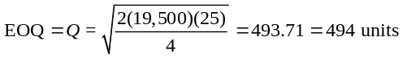
(b) Annual holdings costs = [Q/2]H = [494/2](4) = $988
(c) Annual ordering costs = [D/Q]S = [19500/494](25) = $987
12.6 (a) 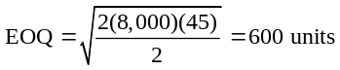
(b) If H doubles, from $2 to $4/unit/month,
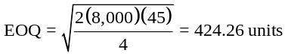
(c) If H drops in half, from $2 to $1/unit/month,
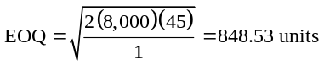
12.7 (a) This problem reverses the unknown of a standard EOQ problem to solve for S.
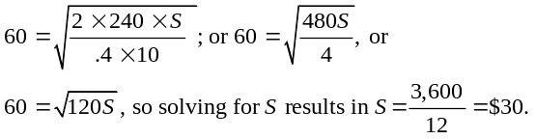

(b) If S were $30, then the EOQ would be 60. If the true ordering cost turns out to be much greater than $30, then the firm’s order policy is ordering too little at a time.
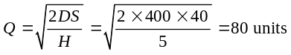12.8 (a) Economic Order Quantity (Holding cost = $5 per year):
where D = annual demand, S = setup or order cost, H = holding cost
(b) Economic Order Quantity (Holding cost = $6 per year):
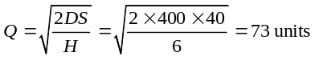
where D = annual demand, S = setup or order cost, H = holding cost
12.9 D = 15,000, H = $25/unit/year, S = $75
(a) 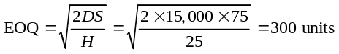
(b) Annual holding costs = (Q/2) × H = (300/2)
× 25 = $3,750
(c) Annual ordering costs = (D/Q) × S = (15,000/300)
× 75 = $3,750
(d) 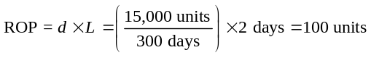

12.10 (a) Reorder point = Demand during lead time
= 100 units/day × 21 days = 2,100 units
(b) If demand during lead time doubles to 200 units/day,
ROP = 200 units/day × 21 days = 4,200 units.
(c) If demand during lead time drops to 50 units/day,
ROP = 50 units/day × 21 days = 1,050 units.
12.11 (a) D = 10,000
Number of business days = 300
Lead time = 5 days
ROP = [Demand/Day](Lead time) = [10,000/300](5)
= 166.67 ≅ 167 units.
(b) This number is important because it helps Duncan keep enough inventory to prevent stockouts while she waits for the new order to arrive.
12.12 (a) 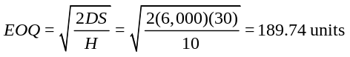
(b) Average inventory = 94.87
(c) Optimal number of orders/year = 31.62
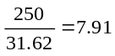
(d) Optimal days between orders =

(e) Cost of inventory management, excluding cost of goods = (31.62 × 30) + (94.87 × 10) = $1,897.30
(f) Total annual inventory cost = $601,897.30 (including the $600,000 cost of goods)
Note: Rounding occurs in answers.
12.13 (a) 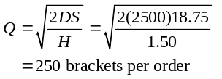
(b) 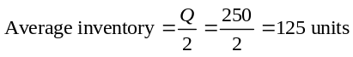
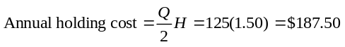
(c) 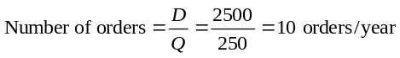
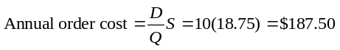
(d) 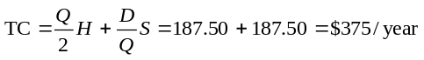
(e) 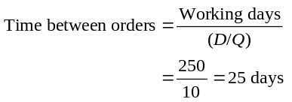
(f) ROP = dL = 10(2) = 20 units (where 10 = daily demand)
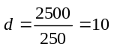
12.14 (a) 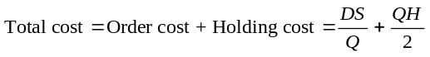
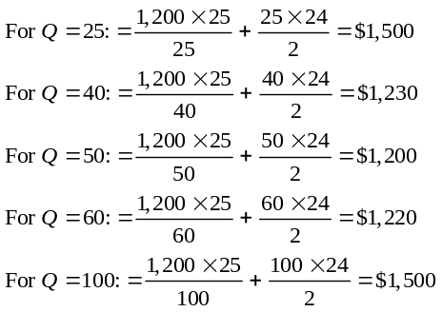
(b) Economic Order Quantity:
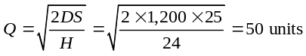
where D = annual demand, S = setup or order cost,
H = holding cost
As expected, small variations in order quantity will not have a significant effect on total costs. If we order twice as many (e.g., Q goes from 25 to 50), TC increases by only $300 (see part a).
12.15 (a) The EOQ assumptions are met, so the optimal order quantity is
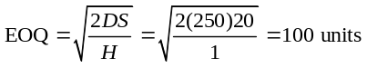
(b) Number of orders per year = D/Q = 250/100 = 2.5 orders per year.
Note that this would mean in one year the company places 3 orders and in the next it would only need
2 orders since some inventory would be carried over from the previous year. It averages 2.5 orders per year.
(c) Average inventory = Q/2 = 100/2 = 50 units
(d) Given an annual demand of 250, a carrying cost of $1, and an order quantity of 150, Patterson Electronics must determine what the ordering cost would have to be for the order policy of 150 units to be optimal. To find the answer to this problem, we must solve the traditional economic order quantity equation for the ordering cost. As you can see in the calculations
that follow, an ordering cost of $45 is needed for the order quantity of 150 units to be optimal.
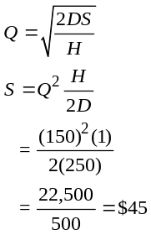

12.16 D = 12,500/year, so d = (12,500/250) = 50/day, p = 300/day, S = $30/order, H = $2/unit/year
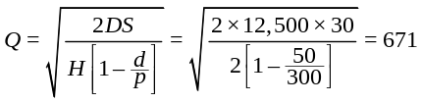
(a)

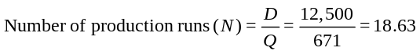
(b)

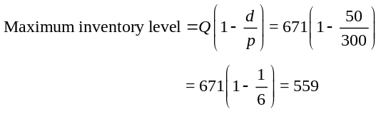
(c)

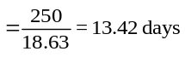 (d) Days of demand satisfied by each production run

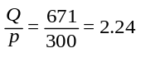 Days in production for each order =
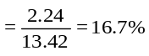 Total time = 13.42 days per cycle.
Thus, percent of time in production

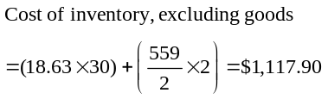 (e)

12.17 Production Order Quantity, noninstantaneous delivery.
(a) D = 12,000/yr
H = $.10/light-yr
S = $50/setup
P = $1.00/light
p = 100/day
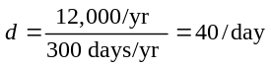
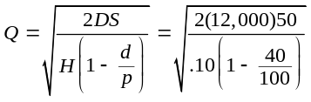
= 4,472 lights per run
(b) 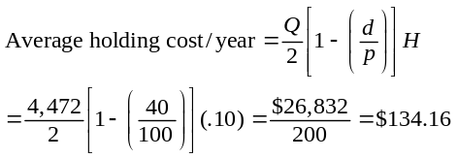
(c)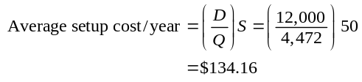
(d) Total cost (including cost of goods)
= PD + $134.16 + $134.16
= ($1 × 12,000) + $134.16 + $134.16
= $12,268.32/year

12.18 (a) Production Order Quantity, noninstantaneous delivery:
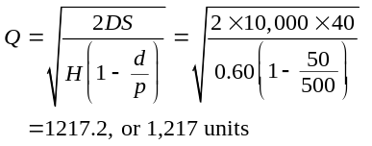
where D = annual demand, S = setup cost,
H = holding cost, d = daily demand rate, p = daily production rate
(b) 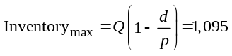
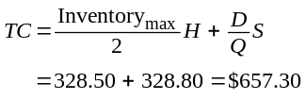 (c) 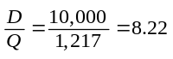
(d)

12.19 At the Economic Order Quantity, we have:
The total costs at this quantity are:
Holding cost = Q/2 × H = 1,000 × .45 = $450
Ordering cost = D/Q × S = 36,000/2,000 × 25 = $450
Purchase cost = D × P = 36,000 × 0.85 = $30,600
Total cost = $900 + $30,600 = $31,500
At the quantity discount, we have:
Holding cost = Q/2 × H = 3,000 × .45 = $1,350
Ordering cost = D/Q × S = 36,000/6,000 × 25 = $150
Purchase cost = D × P = 36,000 × 0.82 = $29,520
Total cost = $1,500 + $29,520 = $31,020
The quantity discount will save $480 on this item. The company should also consider some qualitative aspects of the decision, such as available space, the risk of obsolescence of disks, and the risk of deterioration of the storage medium over time, as 6,000 represents one-sixth of the year’s needs.
12.20 D (Annual demand) = 400 × 12 = 4,800, P (Purchase price/Unit) = $350/unit, H (Holding cost /Unit) = $35/unit/year,
S (Ordering cost/Order) = $120/order. So,
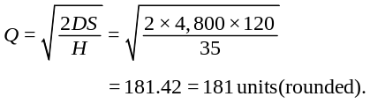
(a)

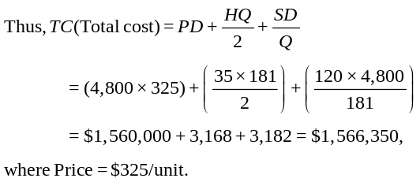

However, if Bell Computers orders 200 units, which is optional with the discount model, then
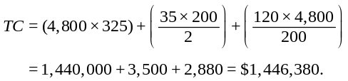

Bell Computers should order 200 units for a minimum total cost of $1,446,380.
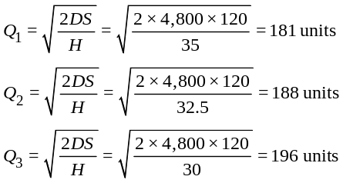
(b)

181 units would not be bought at $350. 196 units cannot be bought at $300, hence that isn’t possible either. So, EOQ = 188 units.
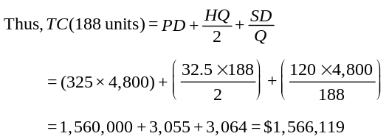

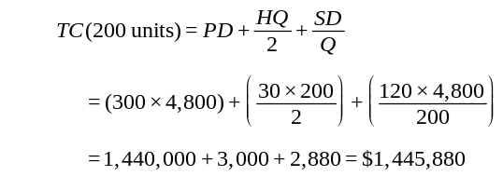

The minimum order quantity is 200 units yet again because the overall cost of $1,445,880 is less than ordering 188 units, which has an overall cost of $1,566,119.
12.21 The solution to any quantity discount model involves determining the total cost of each alternative after quantities have been computed and adjusted for the original problem and every discount.
We start the analysis with no discount:
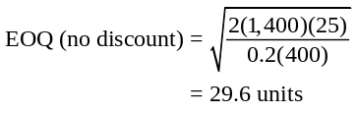
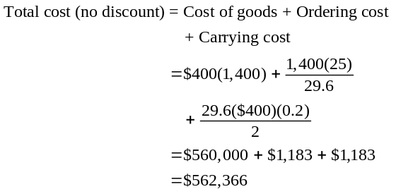
The next step is to compute the total cost for the discount:
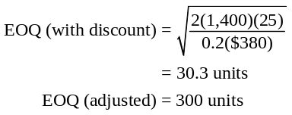
Because this last economic order quantity is below the discounted price, we must adjust the order quantity to 300 units. The adjusted EOQ for 300 units is used to compute total cost.
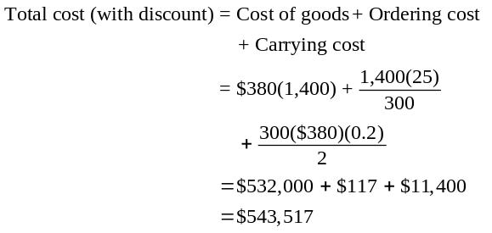
The optimal strategy is to order 300 units at a total cost of $543,517.
12.22
Best option must be determined first. Since all solutions yield Q values greater than 10,000, the best option is the $1.25 price.
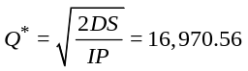
(a)

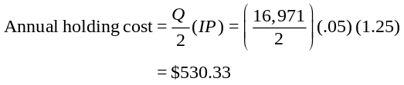(b)

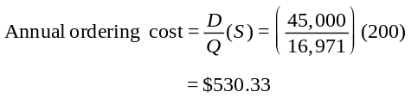
(c) 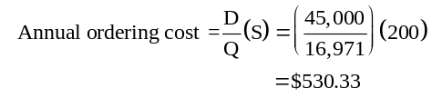

(d) Unit costs = P × D = ($1.25) (45,000) = $56,250
(e) Total cost = $530.33 + $530.33 + 56,250.00 = $57,310.66
12.23 (a) D = 20,000/yr
I = 20 percent of purchase price per year in holding costs, where H = IP
S = $40/order
P = $20/tire if fewer than 500 are ordered;
$18/tire if between 500 and 999 are ordered; and
$17/tire if 1,000 or more are ordered
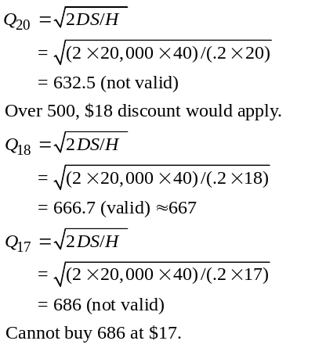
(b) We compare the cost of ordering 667 with the cost of
ordering 1,000:
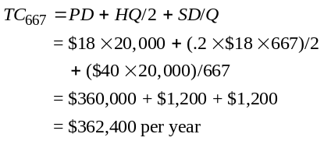
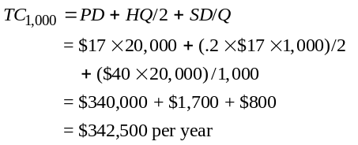
Rocky Mountain should order 1,000 tires each time.
12.24 D = 700 × 12 = 8,400, H = 5, S = 50
Allen
1–499 | $16.00
500–999 | $15.50
1,000+ | $15.00

Baker
1–399 | $16.10
400–799 | $15.60
800+ | $15.10
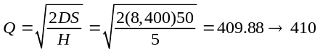
(a)

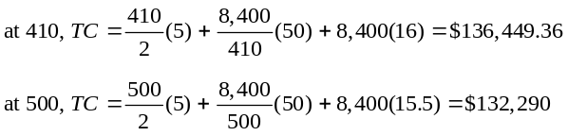(b, c) Vendor: Allen

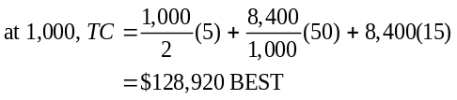

Vendor: Baker
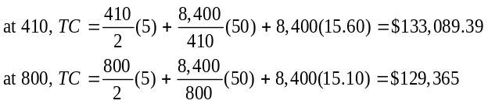

Vendor Allen best at Q = 1,000, TC = $128,920.

12.25 S = 10, H = 3.33, D = 2,400

EOQ = 120 with slight rounding
 |  | Costs
Qty | Price |  | Holding | Ordering | Purchase | Total
120 | $33.55 | $199.80 |  | $200.00 | $80,520.00 | $80,919.80 |  | Vendor A
150 | $32.35 | $249.75 |  | $160.00 | $77,640.00 | $78,049.75
300 | $31.15 | $499.50 |  | $80.00 | $74,760.00 | $75,339.50
500 | $30.75 | $832.50 |  | $48.00 | $73,800.00 | $74,680.50
120 | $34.00 | $199.80 |  | $200.00 | $81,600.00 | $81,999.80 |  | Vendor B
150 | $32.80 | $249.75 |  | $160.00 | $78,720.00 | $79,129.75
300 | $31.60 | $499.50 |  | $80.00 | $75,840.00 | $76,419.50
500 | $30.50 | $832.50 |  | $48.00 | $73,200.00 | $74,080.50 |  | BEST
120 | $33.75 | $199.80 |  | $200.00 | $81,000.00 | $81,399.80 |  | Vendor C
200 | $32.50 | $333.00 |  | $120.00 | $78,000.00 | $78,453.00
400 | $31.10 | $666.00 |  | $60.00 | $74,640.00 | $75,366.00
120 | $34.25 | $199.80 |  | $200.00 | $82,200.00 | $82,599.80 |  | Vendor D
200 | $33.00 | $333.00 |  | $120.00 | $79,200.00 | $79,653.00
400 | $31.00 | $666.00 |  | $60.00 | $74,400.00 | $75,126.00

12.26 Calculation for EOQ: S = $50, I = 50%, H = 50% of P,
D = 9,600
(a) | Price | EOQ |  | Vendor
 | $17.00 | 336.0672 | feasible | 1
 | $16.75 | 338.5659 | not feasible
 | $16.50 | 341.1211 | not feasible
 | $17.10 | 335.0831 | feasible | 2
 | $16.85 | 337.5598 | not feasible
 | $16.60 | 340.0921 | not feasible

(b, c) |  |  | Costs
 | Qty | Price | Holding | Ordering | Purchase | Total
 | 336 | $17.00 | $1,428.00 | $1,428.57 | $163,200.00 | $166,056.57 |  | Vendor 1
 | 500 | $16.75 | $2,093.75 | $960.00 | $160,800.00 | $163,853.75
 | 1000 | $16.50 | $4,125.00 | $480.00 | $158,400.00 | $163,005.00
 | 335 | $17.10 | $1,432.13 | $1,432.84 | $164,160.00 | $167,024.97 |  | Vendor 2
 | 400 | $16.85 | $1,685.00 | $1,200.00 | $161,760.00 | $164,645.00
 | 800 | $16.60 | $3,320.00 | $600.00 | $159,360.00 | $163,280.00
 | 1200 | $16.25 | $4,875.00 | $400.00 | $156,000.00 | $161,275.00 |  | BEST

(d) Other considerations include the perishability of the chemical and whether there is adequate space in
the controlled environment to handle 1,200 pounds of the chemical at one time.
12.27 (a) μ = 60; σ = 7
Safety stock for 90% service level = σZ(at 0.90)
= 7 × 1.28 = 8.96 ≈ 9
(b) ROP = 60 + 9 = 69 BX-5 bandages.
12.28 (a) Z = 1.88
(b) Safety stock = Zσ = 1.88(5) = 9.4 drives
(c) ROP = 50 + 9.4 = 59.4 drives

12.29
 | Incremental Costs
Safety Stock | Carrying Cost | Stockout Cost | Total Cost
0 | 0 | (100 × 0.2 + 200 × 0.2) × 70 = 4,200 | $4,200
100 | 100 × 30 = 3,000 | (100 × 0.2) × 70 = 1,400 | 4,400
200 | 200 × 30 = 6,000 | 0 | 6,000
The safety stock that minimizes total incremental cost is zero units. The reorder point then is 200 units + 0 units, or 200 units.

12.30
 |  | Incremental Costs
Safety Stock | Carrying Cost | Stockout Cost | Total Cost
0 | 0 | 70(100 × 0.4 + 200 × 0.2) = 5,600 | $5,600
100 | 100 × 15 = 1,500 | (100 × 0.2) × (70) = 1,400 | $2,900
200 | 200 × 15 = 3,000 | 0 | $3,000
The safety stock which minimizes total incremental cost is 100 kilos. The reorder point then is 200 kilos +
100 kilos, or 300 kilos.
12.31
Safety  Stock | Additional  Carrying Cost | Stockout Cost | Total  Cost
0 | 0 | 10 × 0.2 × 50 × 7 + 20 × 0.2 × 50 × 7 + 30 × 0.1 × 50 × 7 = 3,150 | 3,150
10 | 10 × 5 = 50 | 50 × 7(10 × 0.2 + 20 × 0.1) = 1,400 | 1,450
20 | 20 × 5 = 100 | 10 × 0.1 × 50 × 7 = 350 | 450
30 | 30 × 5 = 150 | 0 | 150
The BB-1 set should therefore have a safety stock of 30 units; ROP = 90 units.

12.32 Only demand is variable in this problem so Equation
(12-15) applies
(a) ROP = (Average daily demand × Lead time in days)
+ ZσdLT
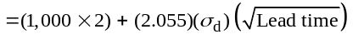
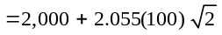
= 2,000 + 291 = 2,291 towels
(b) Safety stock = 291 towels
12.33 Only lead time is variable in this problem, so Equation
(12-16) is used.
Ζ = 1.88 for 97% service level
ROP = (Daily demand × Average lead time in days)
+ Ζ × Daily demand × σLT
ROP = (12,500 × 4) + (1.88)(12,500)(1)
= 50,000 + 23,500 = 73,500 pages
12.34 (a) Both lead time and demand are variables, so Equation
(12-17) applies, in weeks. Ζ = 1.28 for 90% service.
ROP = (200 × 6) + 1.28 σdLT
where σdLT 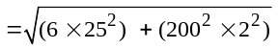

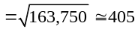
So ROP = 1,200 + (1.28)(405) ≅ 1,200 + 518 = 1,718 cigars
(b) For 95% service level, Z = 1.65
So ROP = (200 × 6) + 1.65(405) ≅ 1,200 + 668 = 1,868 cigars.
(c) A higher service level means a lower probability of stocking out. Hence, the ROP increases from 1,718 to 1,868 when the service level change from part (a) to part (b).
12.35
Holding Cost |  |  | Ordering Cost
$2,000 |  |  | 1,500
600 |  |  | 500
750 |  |  | 800
280 |  |  | 30,000
12,800 |  |  | 500
800 |  |  | 1,000
300 |  |  |  | $34,300
 | $17,530

Note: Items of new product development, advertising, and
research are not part of holding or ordering cost.
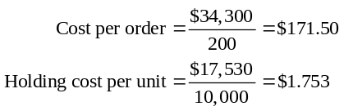
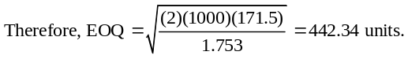
12.36 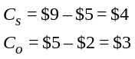
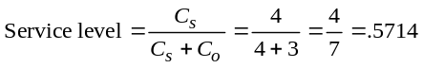
Z ≈ .18, μ = 100, σ = 15
Optimal stocking level = 100 + .18(15) = 102.7, or 103 pounds of oysters.
12.37 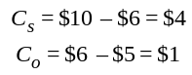
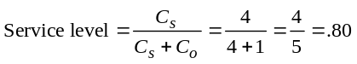
So Z = .84, μ = 25, σ = 4
Optimal stocking level = 25 + .84(4) = 28.36, or 28 cakes.
12.38 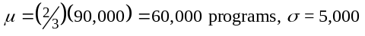
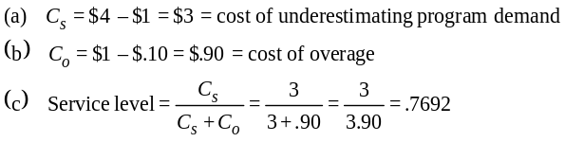So Z ≅ .735 (about halfway in Appendix I between .73 and .74)
Optimal number of programs to order per game
= 60,000 + .735 (5,000) = 60,000 + 3,675
= 63,675
(d) Stockout risk = 1 – Service level = 1 – .7692 = .2308, or 23.1%
12.39 Annual demand, D = 8,000
Daily production rate, p = 200
Setup cost, S = 120
Holding cost, H = 50
Production quantity, Q = 400
(a) Daily demand, d = D/250 = 8,000/250 = 32
(b) Number of days in production run = Q/p = 400/200 = 2
(c) Number of production runs per year = D/Q = 8,000/400 = 20
Annual setup cost = 20($120) = $2,400
(d) Maximum inventory level = Q(1 – d/p)
= 400(1 – 32/200) = 336
Average inventory = Maximum/2 = 336/2 = 168
(e) Total holding cost + Total setup cost = (168)50 + 20(120)
= $8,400 + $2,400
= $10,800
(f) 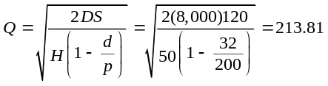
Total holding cost + Total setup cost = 4,490 + 4,490 = $8,980
Savings = $10,800 – $8,980 = $1,820
12.40 (a) d = 75 lbs/day 200 days per year D = 15,000 lb/year
H = $3/lb/year S = $16/order
Q = 400 lb of beans =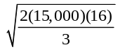
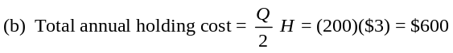
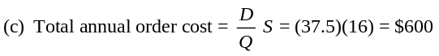
(d) LT = 4 days with σ = 15 Stockout risk = 1%
Ζ = 2.33
ROP = Lead time demand + SS
where SS = (Ζ)(σdLT) and lead time demand = (d)(LT)
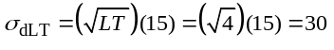
ROP = 369.99 where ROP = (d)(LT) + SS
(e) SS = 69.99 from part (d)
(f) Annual safety stock holding cost = $209.97
(g) 2% stockout level ⇒ Z = 2.054
SS = (Z)(σdLT) = 61.61
The lower we make our target service level, the less SS we need.

ADDITIONAL HOMEWORK PROBLEMS
Here are solutions to additional homework problems 12.41–12.53 which are found on our Web site, www.pearsonglobaleditions.com/myomlab.
12.41
 | Annual
SKU | Demand | Cost ($) | Demand × Cost | Classification
A | 100 | 300 | 30,000 | A
B | 75 | 100 | 7,500 | B
C | 50 | 50 | 2,500 | C
D | 200 | 100 | 20,000 | A
E | 150 | 75 | 11,250 | B
Obviously, with so few items, the breakdowns into A, B, and C cannot follow the guidelines exactly.

12.42
 | Annual |  | Demand ×
Item | Demand | Cost ($) | Cost | Classification
E102 | 800 | 4.00 | 3,200 | C
D23 | 1,200 | 8.00 | 9,600 | A | 27%
D27 | 700 | 3.00 | 2,100 | C
R02 | 1,000 | 2.00 | 2,000 | C
R19 | 200 | 8.00 | 1,600 | C
S107 | 500 | 6.00 | 3,000 | C
S123 | 1,200 | 1.00 | 1,200 | C
U11 | 800 | 7.00 | 5,600 | B | 16%
U23 | 1,500 | 1.00 | 1,500 | C |  | 33%
V75 | 1,500 | 4.00 | 6,000 | B | 17%
12.43 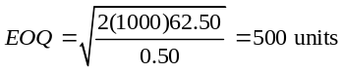
12.44 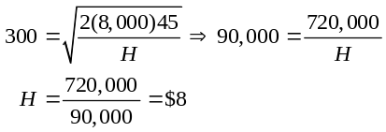
12.45 (a) Economic Order Quantity:
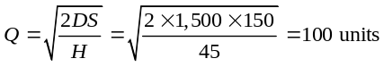
where: D = annual demand, S = setup or order cost,
H = holding cost
(b) 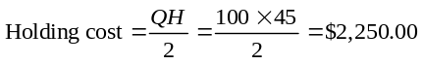
(c) 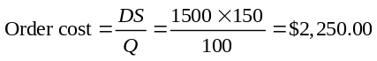
(d) Reorder point:
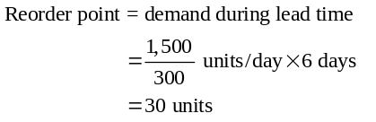
12.46 Reorder point = demand during lead time
= 500 units/day × 14 days
= 7,000 units
12.47 (a) Economic Order Quantity:
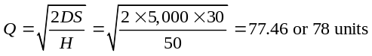
where: D = annual demand, S = setup or order cost,
H = holding cost
(b) Average inventory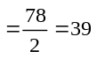units
(c) Number of orders per year 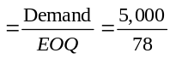
= 64.1 or 64 orders
(d) Assuming 250 business days per year, the optimal number of business days between orders is given by:
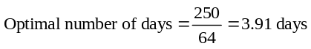
(e) 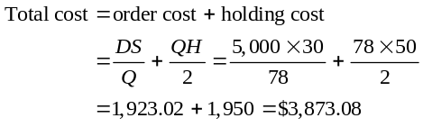
Note: Order and carrying costs are not equal due to rounding of the EOQ to a whole number. If an EOQ of 77.46 is used, the order and carrying costs calculate to $1,936.49 for a total cost of $3,872.98.
(f) Reorder point:
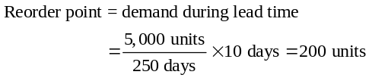
This is not to say that we reorder when there are 200 units on hand (as there never are). The ROP indicates that orders are placed several cycles prior to their
actual demand.
12.48 (a) Total cost = order cost + holding cost 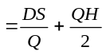
For Q = 50:
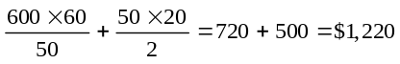
(b) Economic Order Quantity:
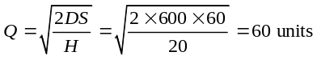
where: D = annual demand, S = setup or order cost,
H = holding cost
For Q = 60:
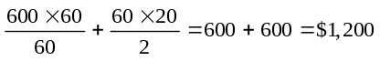
(c) Reorder point:
Reorder point = demand during lead time
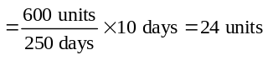
12.49 Economic Order Quantity, noninstantaneous delivery:
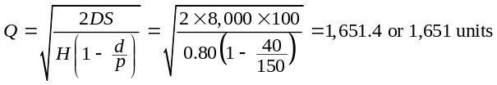
where: D = annual demand, S = setup or order cost, H = holding cost, d = daily demand rate, p = daily production rate
12.50 Economic Order Quantity:
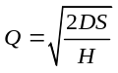
where: D = annual demand, D = setup or order cost, H = holding cost, p = price/unit
(a) Economic Order Quantity, standard price:
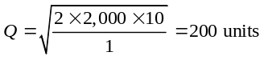
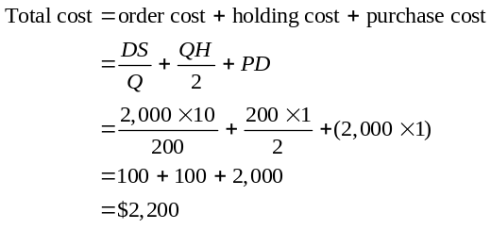
(b) Quantity Discount:
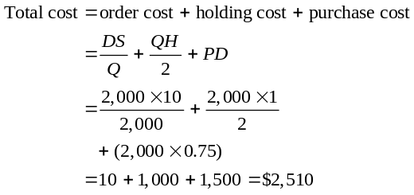
Note: No, EOQ with 200 units and a total cost of $2,200 is better.
12.51 Under present price of $7.00 per unit, Economic Order Quantity:
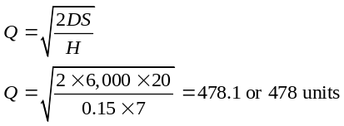
where: D = annual demand, S = setup or order cost, H = holding cost, p = price/unit
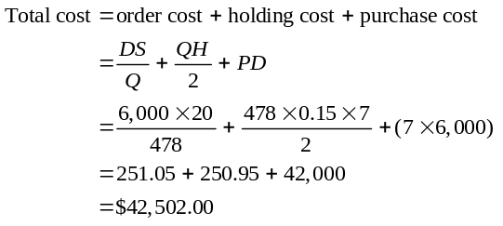
Note: Order and carrying costs are not equal due to rounding of the EOQ to a whole number. Under the quantity discount price of $6.65 per unit:
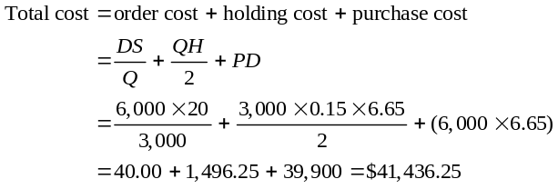
Therefore, the new policy, with a total cost of $41,436.25, is
preferable.
12.52 Economic Order Quantity:
where: D = annual demand, S = setup or order cost, H = holding cost, P = price/unit
(a) Order quantity 9 sheets or less, unit price = $18.00
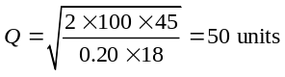
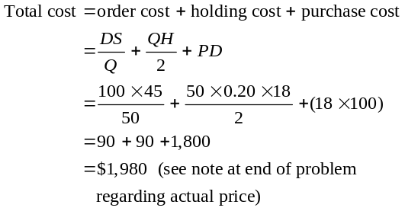
(b) Order quantity 10 to 50 sheets: unit price = $17.50
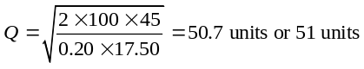
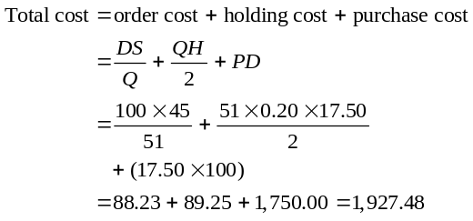
Note: Order and carrying costs are not equal due to rounding the EOQ to a whole number. See note at end of problem regarding price.
(c) Order quantity more than 50 sheets: unit price = $17.25
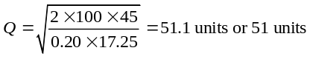
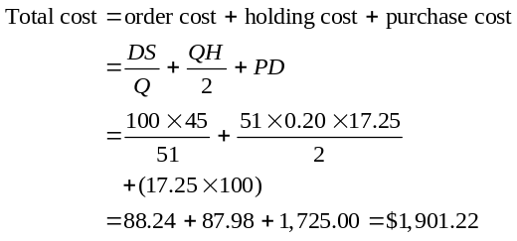
Therefore, order 51 units.
Note: Order and carrying costs are not equal due to rounding of the EOQ to a whole number.
Important Note: Students will likely complete all three sets of calculations, including the calculations of
total costs. They should be prompted to realize that calculations of total cost under (a) and (b) are actually inappropriate because the original assumptions as to lot size would not be satisfied by the calculated EOQs.
12.53 Z = 1.28 for 90% service level
Safety stock = (1.28)(15) = 19.2 or 19
Reorder point = 36 + 19 = 55 TVs

Case Studies
HERRER’S BICYCLE SHOP, TILBURG, THE NETHERLANDS
1
1. Given the data, can you provide advice to Jo on the order quantity and reorder point?

The forecasted demand for all the 12 months of 2010 is 888 bicycles. Hence the average demand per month = 888/12 = 74 bicycles. The standard deviation of the monthly demand = 57.78 bicycles. Other parameters of the problem are given below.

Order cost = $100/order
Cost per bicycle = $200
Holding cost = ($200) × (18%) = $36 per year per bicycle

Using the simple EOQ model, the economic order quantity (Q*) is calculated as follows.
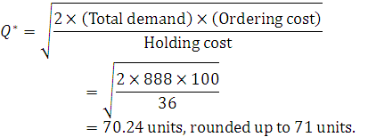

Service level = 95%, with corresponding Z value of 1.645
Lead time = 1 month (4 weeks)

The reorder point (ROP) is calculated by the following relation:

ROP = Average demand during the lead time (µ)
+ Z × (Standard deviation of the demand during the lead time (σ)

Therefore, ROP = 74 + 1.645 (57.78) = 169.01 bicycles (rounded up to 170).

2. If Jo wanted to increase service to 99%, what would the new reorder point be? How much additional holding costs would result?

For 99% service level, Z value is 2.326. Hence the new reorder point is,

ROP = 74 + 2.326 (57.78) = 208.39 bicycles (rounded up to 209)

Thus, with the new service level, the reorder point is 209 units. This represents 39 additional units of safety stock, or an additional $1404 in holding cost per annum.

3. What critical assumption is not met in the analysis above? What improvements on the policy can you imagine?

The EOQ model assumes a constant demand which is not the case here. That said, the EOQ model is notoriously robust. More critical is basing the ROP on average monthly demand and standard deviations. This will lead to an increased chance of a stockout during the peak demand months. A better policy would be to calculate a reorder point which changes based on the month.

Data
 | 2008 | 2009 | 2010 Forecast
Jan | 12 | 14 | 16
Feb | 23 | 26 | 30
Mar | 43 | 51 | 59
Apr | 83 | 97 | 113
May | 162 | 193 | 225
Jun | 83 | 97 | 113
Jul | 62 | 73 | 85
Aug | 33 | 39 | 45
Sep | 21 | 25 | 29
Oct | 22 | 25 | 29
Nov | 42 | 51 | 59
Dec | 61 | 73 | 85

STURDIVANT SOUND SYSTEMS
2
1. Compute the optimal order quantity. First, determine the cost under the present policy:
Number of orders/year = 52 weeks ÷ 4 weeks = 13 orders
Average order size = 5,000/13 = 384.6 or 385 units
Total cost = order cost + holding cost + purchase cost
Purchase cost = 5000 units × 60/unit = 300,000
Order cost = $20/order × 13 orders = 260
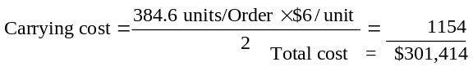

Note: Did not round 384.6 above.
Next, develop an Economic Order Quantity and determine the total costs:
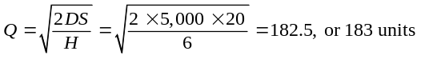

where D = annual demand, S = setup or order cost, H = holding cost.
2. Determine the appropriate reorder point (in units).
Reorder point = Demand during lead time = 20 × 5 = 100
3. Compute the cost savings that the company will realize if it implements the optimal inventory procurement decision.
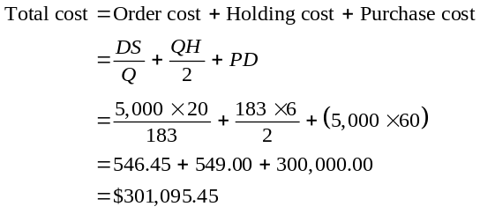
Note: Order and carrying costs are not equal due to rounding of the EOQ to a whole number.
The cost savings under the EOQ ordering policy would then be:
Cost under present policy: $301,414.00
Cost under EOQ policy: 301,095.45
$ 318.55
which is a very small savings.
4. The typical costs associated with procurement of materials
include costs of preparing requisitions, writing purchase orders, receiving merchandise, inspecting goods, storage, updating inventory records, and so forth. These costs are usually fixed, regardless of the size of the order. A large order may require more processing time (in inspection, for example), but the increase in procurement costs is typically minimal. As lot size increases, the number of orders decreases (assuming a constant requirement level). Consequently, procurement costs typically decrease with an increase in lot size.
Video Case Studies
MANAGING INVENTORY AT FRITO-LAY
1
This video, filmed specifically for our text, is available from
Prentice Hall and is designed to supplement this case.
1. A process-focused facility will have substantial raw material for the unexpected order, substantial WIP because of imbalance in the system, few finished goods because most items are made to order, and less MRO because of optional routings in the plant.
2. The major inventory items at Frito-Lay are potatoes, corn, corn meal, seasonings, and oil. They move quickly through the process, usually in hours. At the Florida plant, for example, potatoes arrive by the truckload from nearby farms, and 50,000 pounds (10 truckloads) are consumed in one shift. Only about 7½ hours of potatoes are held in the storage area.
3. Four types of inventory:
(a) Raw materials: potatoes, corn, seasonings, and oil
(b) Work-in-process: potatoes being cleaned, seasoned,
cooked, and bagged
(c) Finished goods: bags and cartons of chips or other products
(d) MRO: motors, gears, and switches that keep the plant running
4. Dollar investments in each of the above four types of inventory:
(a) Least: WIP—There is virtually no WIP—only one shift worth that is moving rapidly through the plant.
(b) Next to least: Raw material with frequent delivery will have low volume on hand at any one time.
(c) Next to most: Finished goods—Several days of inventory but with an average of 1.4 days, to ensure that proper mix is available for delivery. This is more costly as it has both the raw material cost and the processing cost included.

(d) Most: MRO (maintenance repair and operating supplies)—This inventory is typically high in process industries because replacement parts must be available to keep the high capital investment process running. Good/high utilization requires this.
5. Inventory flows quickly because the plant is automated and efficient, and it suffers minimal breakdowns. It has to move rapidly because the basic corn and potato ingredients are perishable until they are processed and sealed in bags.
6. The firm has plants throughout the United States and Canada (30 of them) because the product must move to market quickly to keep it fresh. So the manufacturing process needs to be near the consumer and markets.
7. Frito-Lay does not make all 41 products at each plant. Equipment to handle specialty products that have (relatively) smaller sales is expensive. So some plants make only a few products and distribute them more broadly. It’s a cost issue.

INVENTORY CONTROL AT WHEELED COACH
2
The 7-minute video, filmed specifically for this text, is available from Pearson Education and designed to supplement this case.
1. Wheeled Coach implements ABC analysis by identifying the annual use of those high dollar items and classifying them as A. They represent some 15% of the total inventory items, but
70%–80% of the total cost. B items are those items that are of medium value that represent 30% of the items and 15%–25% of the value. The low dollar items are class C items, which represents 5% of the annual dollar volume, but about 55% of the total items.
2. The inventory control manager at Wheeled Coach would want to not only have ABC analysis but implement tight physical control of the stockroom. He would also implement a cycle counting system, and ensure that issues require engineering change notices for those items not initially included on the bill of material. To the extent feasible, stockrooms would be consolidated.
3. The inventory control manager would implement these changes through effective leadership, hiring and training of cycle counters, and effective training and education of all staff, from engineering through cycle counters, so that each understands the entire system and the importance of maintaining accurate inventory. We would also want to be assured that all concerned employees understand the importance of accurate inventory records, tight inventory control, and locked stockrooms. Management would have to exhibit the proper leadership and support of the entire system, including accurate bills of material, rapid issuing of ECNs, training budgets, etc.
Additional Case Studies*
SOUTHWESTERN UNIVERSITY: F
1
Key Points: This case lets the student look at a simple inventory problem that can be discussed at several levels. By using a standard EOQ formula, the student gets a fast, easy solution that is close. However, the case lends itself to further discussion that can make the limitations of EOQ readily apparent.
*These case studies appear on our Companion
Web site, www.pearsonglobaleditions.com/heizer.

1. Because this is a one-year demand, demand violates the EOQ assumption of constant demand. Therefore, the number of orders should not be prorated (as does the standard EOQ computation) nor are all orders at the EOQ optimum of 60,000. The total cost and total profit will not be accurate if the theoretical solution is used.
Theoretical Solution: Maddux should order 60,000 per order from First Printing. The simple theoretical EOQ solution is 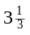 orders of 60,000 each for a setup cost of $1,000, and the total is $310,600. The instructor can accept this as less than precise, but adequate. The solution is close because the total EOQ line is so flat (robust) around the optimum. Alternatively, the instructor can expand the discussion to the real application.
Excel OM software output (theoretical solution) is shown
below:
 |  | Data
Demand rate, D | 200,000
Setup cost, S | 300
Holding cost %, I | 0.5
 | Range 1 | Range 2 | Range 3 | Range 4
Minimum quantity | 10,000 | 30,000 | 60,000 | 250,000
Unit price, P | 1.62 | 1.53 | 1.44 | 1.26

Actual Solution: The demand is not constant. Maddux needs 200,000 programs this year. The programs will be different next year when he will also have a new forecasted demand, depending on how the team does this year. Maddux’s real solution will be more like this one: Maddux should order programs from First Printing. He places 3 orders for 60,000 and 1 for 20,000 at an actual total cost of $308,800.
 |  | Results
 | Range 1 | Range 2 | Range 3 | Range 4
Q* (Square root form) | 12,171.61 | 12,524.48 | 12,909.94 | 13,801.31
Order quantity | 12,171.61 | 30,000.00 | 60,000.00 | 250,000.00
Holding cost | $4,929.50 | $11,475.00 | $21,600.00 | $78,750.00
Setup cost | $4,929.50 | $2,000.00 | $1,000.00 | $240.00
Unit costs | $324,000.00 | $306,000.00 | $288,000.00 | $252,000.00
Total cost | $333,859.01 | $319,475.00 | $310,600.00 | $330,990.00

Theoretical unit cost = ($1.44 × 200,000) = $288,000
Actual unit cost = ($1.44 × 3 × 60,000) + ($1.53
× 20,000) = $259,200 + $30,600
= $289,600
Theoretical ordering cost = (× $300) = $1,000
Actual ordering cost = but in fact 4 orders must be placed;
3 at 60,000 and 1 at 20,000. Four setups cost $1,200 = (4 × $300)
Theoretical holding cost = 50% of $1.44 × (60,000/2) = $21,600
Actual holding cost = Last order is for only 20,000 units, so his average order (and maximum inventory) is only 50,000 (200,000/4 orders or [(3 × 60,000) + 20,000]/4 = 50,000, so a case can be made that his holding cost is 50% of 1.44 × (50,000/2) = $18,000.
Total program cost = (Unit cost) + (Ordering cost)
+ (Holding cost)
= $289,600 + $1,200 + $18,000
= $308,800
2. The insert ordering includes another set of issues. Although some students might use a standard quantity discount model and suggest that the order quantity should be 60,000 units, purchased from First Printing, as shown in the Excel OM printout below, the real problem is somewhat different:
 |  | Data
Demand rate, D | 200,000
Setup cost, S | 300
Holding cost %, I | 0.05
 | Range 1 | Range 2 |  | Range 3 |  | Range 4
Minimum quantity | 10,000 | 30,000 |  | 60,000 |  | 250,000
Unit price, P | 0.81 | 0.765 |  | 0.72 |  | 0.63

 |  | Results
 | Range 1 | Range 2 | Range 3 | Range 4
Q* (Square root form) | 54,433.1 | 56,011.2 | 57,735.0 | 61,721.3
Order quantity | 54,433.1 | 56,011.2 | 60,000 | 250,000
Holding cost | $1,102.27 | $1,071.21 | $1,080.00 | $3,937.50
Setup cost | $1,102.27 | $1,071.21 | $1,000.00 | $300.00
Unit costs | $162,000.00 | $153,000.00 | $144,000.00 | $126,000.00
Total cost | $164,204.54 | $155,142.43 | $146,080.00 | $130,237.50

Maddux needs 40,000 inserts for each game and must order them on a per game basis. Inserts for each game are unique, as statistics and lineup for each team changes as the season progresses. If 60,000 people are going to attend the game, then 40,000 inserts are required (2 of 3 people, or 2/3 of 60,000). Therefore, the quantity discount issue, although it should be evaluated, takes second place to the necessity of ordering 40,000 inserts for each game.
Therefore, Maddux should order 40,000 inserts from First Printing for each game at a cost of $32,430 per game and 5 × 32,430 (5 games) = $162,150 per season.
Unit cost = $0.765 × 40,000 = $30,600
Ordering cost = 5 orders must be placed @ 40,000 inserts;
5 setups cost $1,500 @ $300 each.
Holding cost = 5% of $0.765 × (40,000/2) = $1,530 (assume average inventory is 20,000).
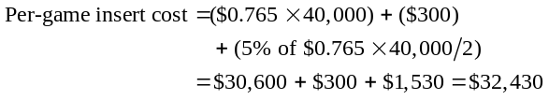
Per-season insert cost = $32,430 × 5 games = $162,150
3. Total cost for the season is: Programs = $308,800
Inserts = $198,750
Total cost for season = $507,550
4. Maddux might do several things to improve his supply chain:
- Ask the potential vendors if there is an additional discount if he buys programs and inserts from the same vendor.
- Ask if he can have the same discount schedule if he places a blanket order for all 200,000, but asks for releases on a per game basis.
- He may also be able to save money if he can reduce his trips to Ft. Worth by combining pickups of programs and inserts.
- He might also prevail upon the vendors to hold the programs and inserts at the printing plant until just before the game, reducing his holding cost.

LAPLACE POWER AND LIGHT
2
The optimal order quantity is given by:
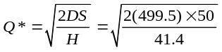
Q* = 34.74 thousand feet
The reorder point is given by:
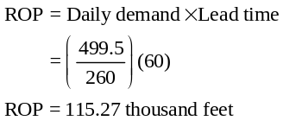
Currently, the company is committed to take 1/12 of its annual need each month. Therefore, each month the storeroom issues
a purchase requisition for 41,625 feet of cable.
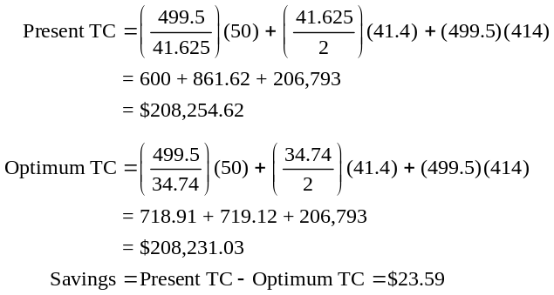
Ordering costs are assumed to be a linear function because no matter how large an order is or how many orders are sent in, the cost to order any material is $50 per order.
The student should recognize that it is doubtful the firm will or should alter any current ordering policy for a savings of only $23.

